Term 2 Assessment Task 3 2006 Theory
Section A: Multiple Choice (1 mark each)

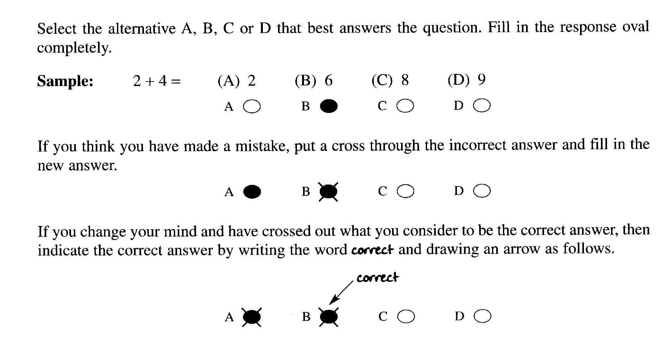

Indicate your answer on the answer grid on page 3

1. Fatty acids containing which range of number of carbon atoms are commonly used for soap-
making?

(A) from C₆ - C₁₀
(B) from C₁₀ - C₂₀
(C) from C₂₀ - C₃₀
(D) from C₃₀ – C₄₀

2. The production of sulfuric acid requires the oxidation of sulfur. What is the change in oxidation
number of sulfur in sulfur dioxide compared to that in sulfuric acid?

(A) 2 to 4
(B) 4 to 6
(C) 2 to 6
(D) 4 to 8

3. Identify the diagrammatic representation of the shapes and electrical charges of corresponding
surfactant molecules

(i) 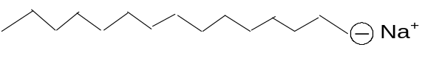

(ii) 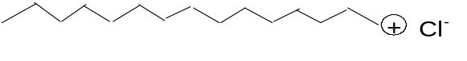

(iii) 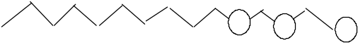

(iv) 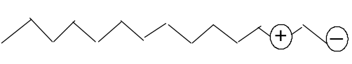

 | Anionic | Cationic | Non-ionic
(A) | (i) | (ii) | (iii)
(B) | (ii) | (i) | (iii)
(C) | (iv) | (ii) | (iii)
(D) | (v) | (i) | (iii)

4. 1.0 kg. of sodium hydrogen carbonate was heated and a complete reaction occurred

2NaHCO₃(s) → Na₂CO₃(s) + CO₂(g) + H₂O (g)

What volume of carbon dioxide gas would be produced at 100 kPa and 25ºC?

(A) 11.9 L
(B) 147.5 L
(C) 295 L
(D) 590.2 L

Section A Student Number………………

Multiple Choice Answer Grid

1. A O B O C O D O

2. A O B O C O D O

3. A O B O C O D O

4. A O B O C O D O

Section B: Short Answer Questions

Question 5 (6 marks) MARKS

Sulfuric acid is often described as the world’s most important industrial chemical because of
the great variety and importance of the uses to which it is put.

(a) Identify one important substance which requires sulfuric acid for its production. 1

...............................................................................................................................................

(b) Using equations, only, outline the three main steps in the contact process. 3

..............................................................................................................................................

..............................................................................................................................................

..............................................................................................................................................

..............................................................................................................................................

..............................................................................................................................................

Question 5 continues next page..
MARKS
- Describe the result for a dehydration experiment using concentrated sulfuric acid and the
safe work practices that were employed. 2

..............................................................................................................................................

..............................................................................................................................................

..............................................................................................................................................

..............................................................................................................................................

..............................................................................................................................................

..............................................................................................................................................

Question 6 (4 marks)

The Solvay process has been in use since the 1860’s.

- What is the Solvay process used to manufacture? 1

..............................................................................................................................................

- Identify one use for this substance? 1

..............................................................................................................................................

- During the Solvay process ammonia is used and converted to ammonium chloride.

(i) Name the substance that is mixed with ammonium chloride in order to recover the
ammonia? 1

..............................................................................................................................................

(ii) Write a balanced chemical equation to show the recovery of ammonia. 1

..............................................................................................................................................

MARKS
Question 7 (6 marks)

Two of the three electrolysis methods used to produce sodium hydroxide are the diaphragm process and the mercury process. Distinguish between the two processes by describing the reactions involved and comparing the purity of the product(s) in each process. 6

.............................................................................................................................................................

............................................................................................................................................................

............................................................................................................................................................

............................................................................................................................................................

............................................................................................................................................................

............................................................................................................................................................

............................................................................................................................................................

............................................................................................................................................................

............................................................................................................................................................

............................................................................................................................................................

............................................................................................................................................................

............................................................................................................................................................

............................................................................................................................................................

............................................................................................................................................................

Test continues next page
MARKS
Question 8 (4 marks)
Imagine you are an organic chemist and you are to design a new laundry detergent for washing oily and soiled clothes . Describe the structure of the detergent molecule you will synthesise and explain how it works. 4
............................................................................................................................................................
............................................................................................................................................................
............................................................................................................................................................
............................................................................................................................................................
............................................................................................................................................................
............................................................................................................................................................
............................................................................................................................................................
............................................................................................................................................................
............................................................................................................................................................
............................................................................................................................................................
............................................................................................................................................................
............................................................................................................................................................
............................................................................................................................................................
............................................................................................................................................................
............................................................................................................................................................

END of TEST

